DESCRIPTION

Create an automated test environment for continuous evaluation of the application.

**Background of the problem statement:**  
An entertainment company like BookMyShow where users book their tickets have multiple users accessing their web app. Due to less infrastructure availability, they use less machines and provide the required structure. This method includes many weaknesses such as:

* Developers must wait till the complete software development for the test results.
* There is a huge possibility of bugs in the test results.
* Delivery process of the software is slow.
* The quality of software is a concern due to continuous feedback referring to things like coding or architectural issues, build failures, test conditions, and file release uploads.

The objective is to implement the automation of the build and release process for  
their product.

**Implementation requirements:**

1. Set up the Jenkins server in master or slave architecture
2. Use the Jenkins plugins to perform the computation part on the Docker containers
3. Create Jenkins pipeline script
4. Use the GIT web hook to schedule the job on check-in or poll SCM
5. Build an image using the artifacts and deploy them on containers
6. Remove the container stack after completing the job

**The following tools must be used:**

1. EC2
2. Jenkins
3. Docker
4. Ansible, Chef, or Puppet

**The following things to be kept in check:**

1. You need to document the steps and write the algorithms in them.
2. The submission of your GitHub repository link is mandatory. In order to track your tasks, you need to share the link of the repository.
3. Document the step-by-step process starting from creating test cases, then executing it, and recording the results.
4. You need to submit the final specification document, which includes:

* Project and tester details
* Concepts used in the project
* Links to the GitHub repository to verify the project completion
* Your conclusion on enhancing the application and defining the USPs (Unique Selling Points)

DESCRIPTION

Create a CI/CD Pipeline to convert the legacy development process to a DevOps process.

**Background of the problem statement:**  
A leading US healthcare company, **Aetna**, with a large IT structure had a 12-week release cycle and their business was impacted due to the legacy process. To gain  
true business value through faster feature releases, better service quality, and cost optimization, they wanted to adopt agility in their build and release process.  
The objective is to implement iterative deployments, continuous innovation, and automated testing through the assistance of the strategy.

**Implementation requirements:**

1. Install and configure the Jenkins architecture on AWS instance
2. Use the required plugins to run the build creation on a containerized platform
3. Create and run the Docker image which will have the application artifacts
4. Execute the automated tests on the created build
5. Create your private repository and push the Docker image into the repository
6. Expose the application on the respective ports so that the user can access the deployed application
7. Remove container stack after completing the job

**The following tools must be used:**

1. EC2
2. Jenkins
3. Docker
4. Git

**The following things to be kept in check:**

1. You need to document the steps and write the algorithms in them.
2. The submission of your Github repository link is mandatory. In order to track your tasks, you need to share the link of the repository.
3. Document the step-by-step process starting from creating test cases, the executing it, and recording the results.
4. You need to submit the final specification document, which includes:
5. Project and tester details
6. Concepts used in the project
7. Links to the GitHub repository to verify the project completion
8. Your conclusion on enhancing the application and defining the USPs (Unique Selling Points)

To solve the above problem, the solution is the following

* 1. The organization decided to invest on ansible due to lack of complexity and ease of use.
  2. Git will be choice of source control management tool.
  3. Move to a cloud infrastructure to automate the infrastructure
  4. Ansible will use to provision ec2 insurances in cloud.

Design Document

Use the below commands on Ubuntu system to install ansible software.

**sudo apt-get install -f**

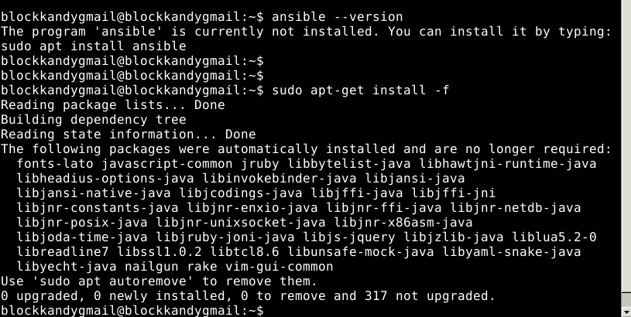

**sudo apt-get install software-properties-common**

**sudo apt-add-repository ppa:ansible/ansible**

**sudo apt-get update**

**sudo apt-get install ansible**

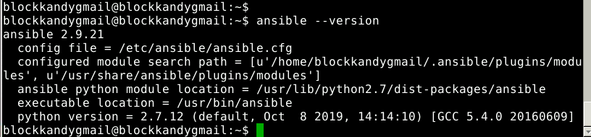

Project 3

Install Jenkins

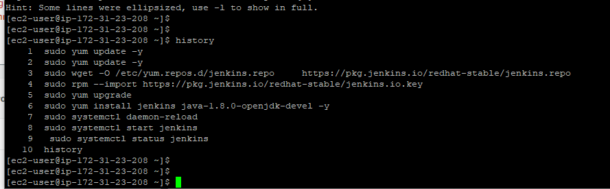

Jenkins status

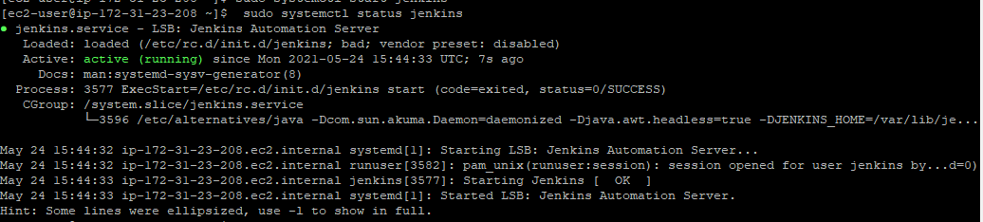

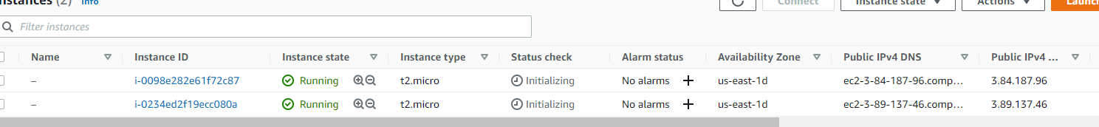

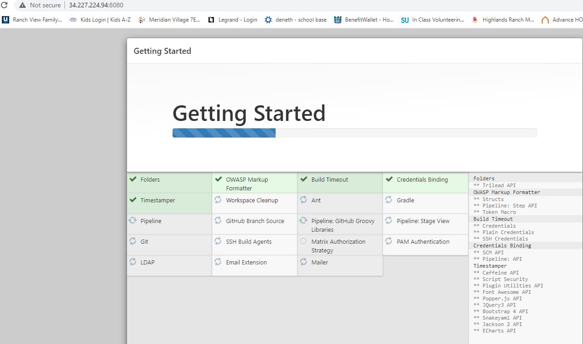

Install Docker

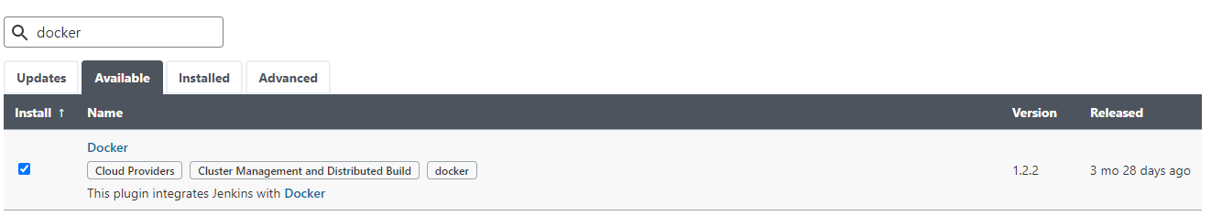

ubuntu@ip-172-31-25-48:~$ history

1 sudo apt-get update

2 sudo apt-get install apt-transport-https ca-certificates curl gnupg-agent software-properties-common

3 curl -fsSL https://download.docker.com/linux/ubuntu/gpg | sudo apt-key add -

5 sudo apt install docker.io

6 sudo apt install docker-compose

7 history

ubuntu@ip-172-31-25-48:~$

Docker is up and running in EC2 ubuntu instance

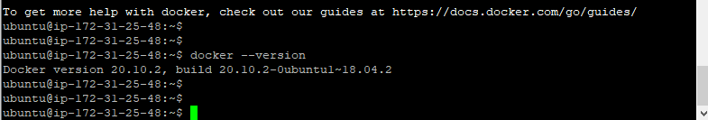

Configure Jenkins server to connect to Docker server ec2 instance via ssh and test the connection

Generate a key in Jenkins server

Add the private key to the Jenkins

Copy and paste the public key in to the Authorize key’s in Docker server

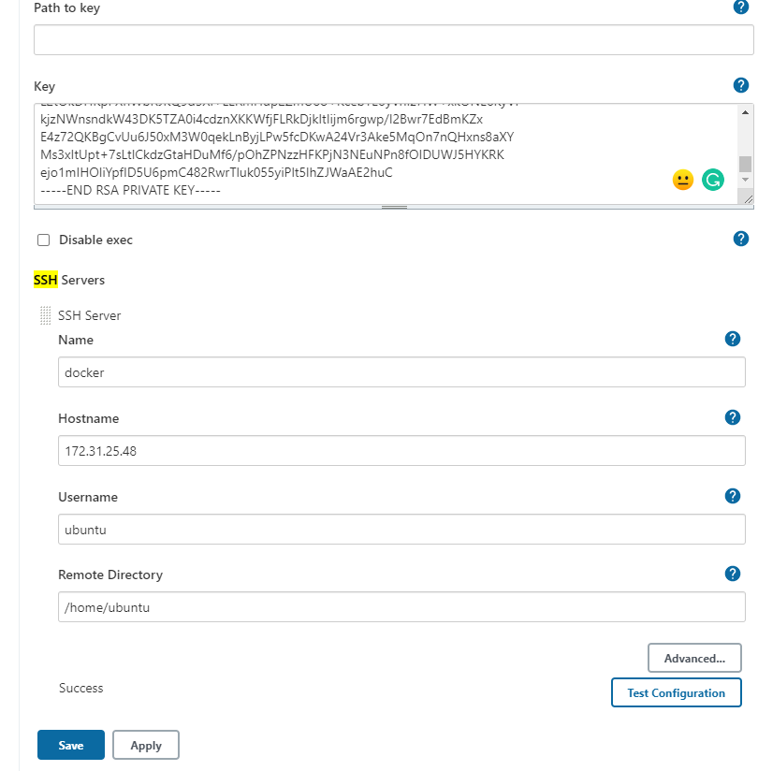

Jenkins setup on Ubuntu

ubuntu@ip-172-31-29-135:~$ history

1 sudo yum update –y

2 wget -q -O — https://pkg.jenkins.io/debian/jenkins-ci.org.key | sudo apt-key add -

3 sudo apt-get install openjdk-8-jdk

4 sudo apt-get install openjdk

5 sudo apt-get install nginx

6 sudo apt-get install openjdk-8-jre

7 sudo apt-get install openjdk-11-jdk

8 wget -q -O - https://pkg.jenkins.io/debian/jenkins-ci.org.key | sudo apt-key add -

9 sudo sh -c 'echo deb http://pkg.jenkins.io/debian-stable binary/ > /etc/apt/sources.list.d/jenkins.list'

10 sudo apt-get update

11 sudo apt-get install jenkins

12 sudo sh -c 'echo deb http://pkg.jenkins.io/debian-stable binary/ > /etc/apt/sources.list.d/jenkins.list'

13 sudo apt-get install jenkins

14 wget -q -O - https://pkg.jenkins.io/debian-stable/jenkins.io.key | sudo apt-key add -

15 sudo apt-get update

16 sudo apt-get install jenkins

17 cat /var/lib/jenkins/secrets/initialAdminPassword

18 sudo cat /var/lib/jenkins/secrets/initialAdminPassword

Install docker in node1 and node2

Follow the document

<https://www.youtube.com/watch?v=8gEs_zefNYA>

mkdir docker-registry

<http://selftuts.com/how-to-host-you-own-docker-registry/>

create a directory before and after (volume)

mkdir volume

Docker user update

ubuntu@ip-172-31-30-188:~/docker-registry$ sudo groupadd docker

groupadd: group 'docker' already exists

ubuntu@ip-172-31-30-188:~/docker-registry$ sudo usermod -aG docker $USER

ubuntu@ip-172-31-30-188:~/docker-registry$ newgrp docker

ec2 instance -as node 1

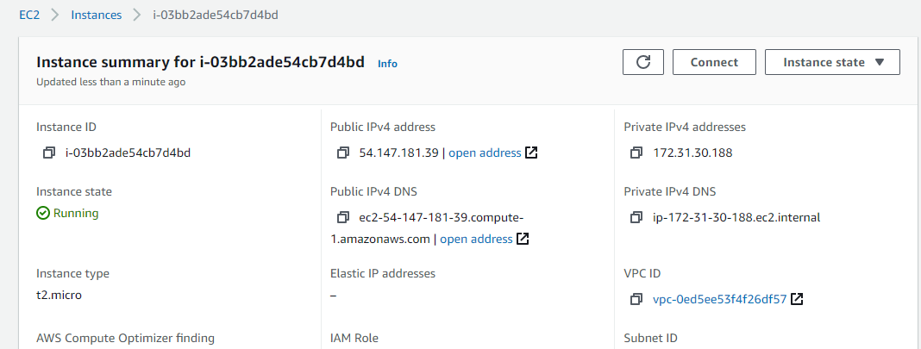

Docker registry access using url

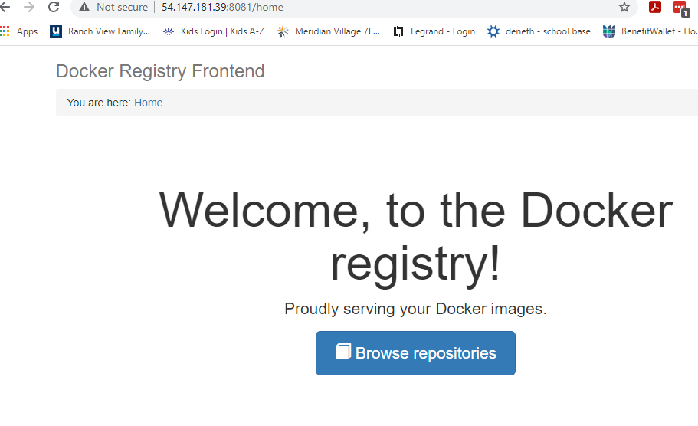

sudo groupadd docker

sudo usermod -aG docker $USER

newgrp docker

docker-compose -f docker-compose.yml up

4. Open the brower and enter the public URL to access local docker registry

eg: http://54.147.181.39:8081/home

http://ec2-54-147-181-39.compute-1.amazonaws.com:8081/home

5. Move to node1 and do the following

1. mkdir registry-app

2. cd registry-app

3. sudo vi /etc/hosts

4. add the entry to access the local docker registry

54.147.181.39 ec2-54-147-181-39.compute-1.amazonaws.com:8081/

5. update the following and add the entry

sudo vi /etc/docker/daemon.json

{

"insecure-registries" : ["ec2-54-147-181-39.compute-1.amazonaws.com:5000"]

}

6. Do the following steps

sudo service docker stop

sudo service docker start

docker images

docker pull alpine

update the image locally

docker tag alpine:latest ec2-54-147-181-39.compute-1.amazonaws.com:5000/lalith:v1

push to the registry

docker push ec2-54-147-181-39.compute-1.amazonaws.com:5000/lalith:v1

Check the local repo

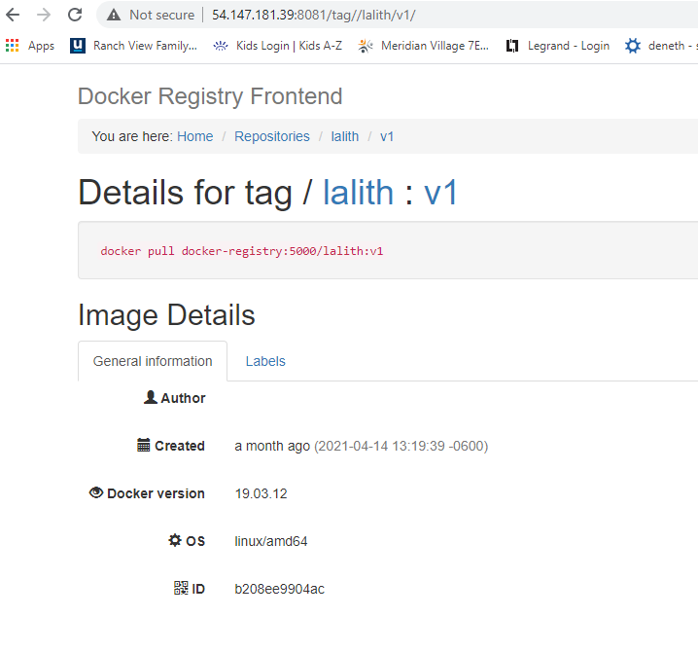

docker rmi <image> to remove it locally

Configure cloud

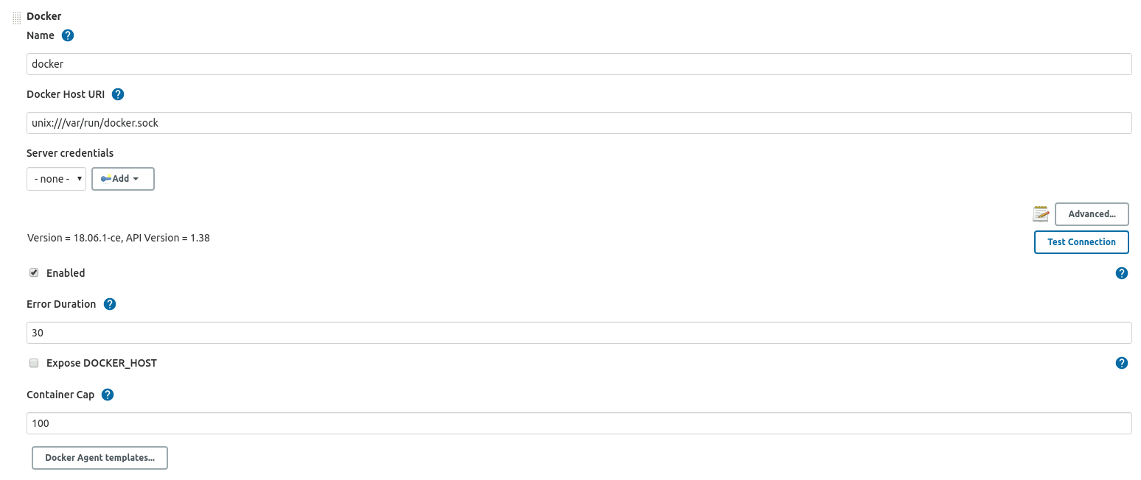

\

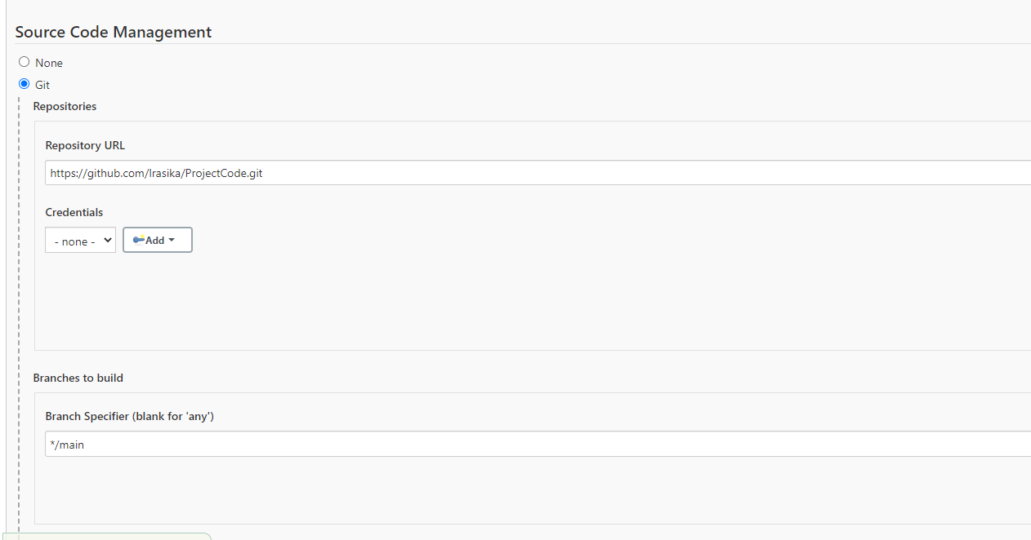

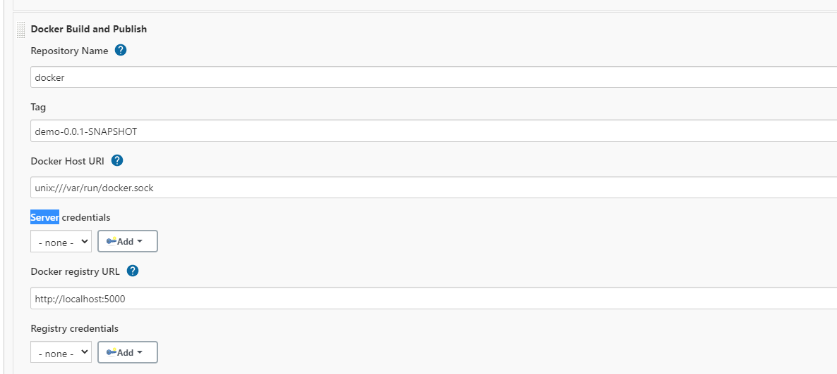

AWS dashboard

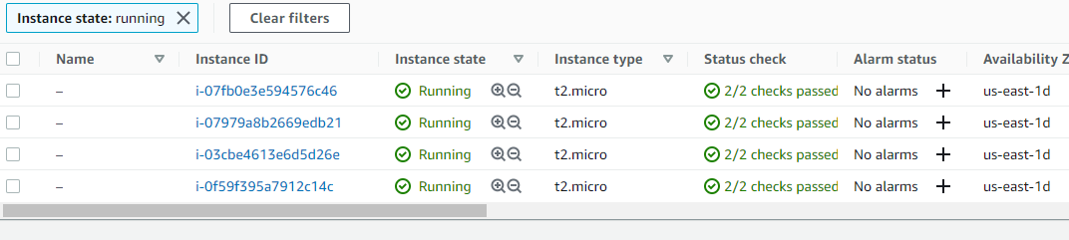

Docker Clouds Configuration in Jenkins

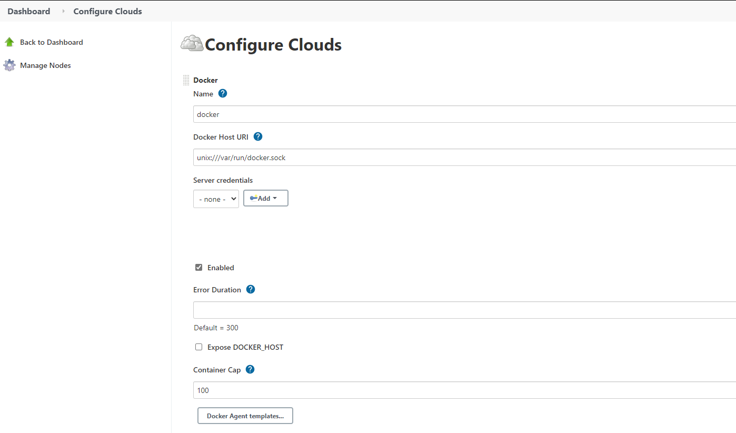

https://github.com/lrasika/phpApp.git

Jenkins job status

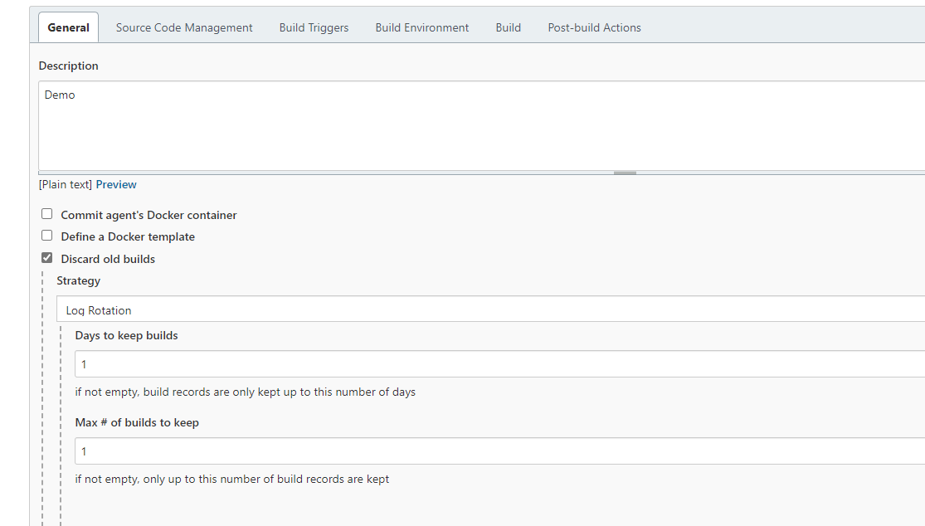

Source code management

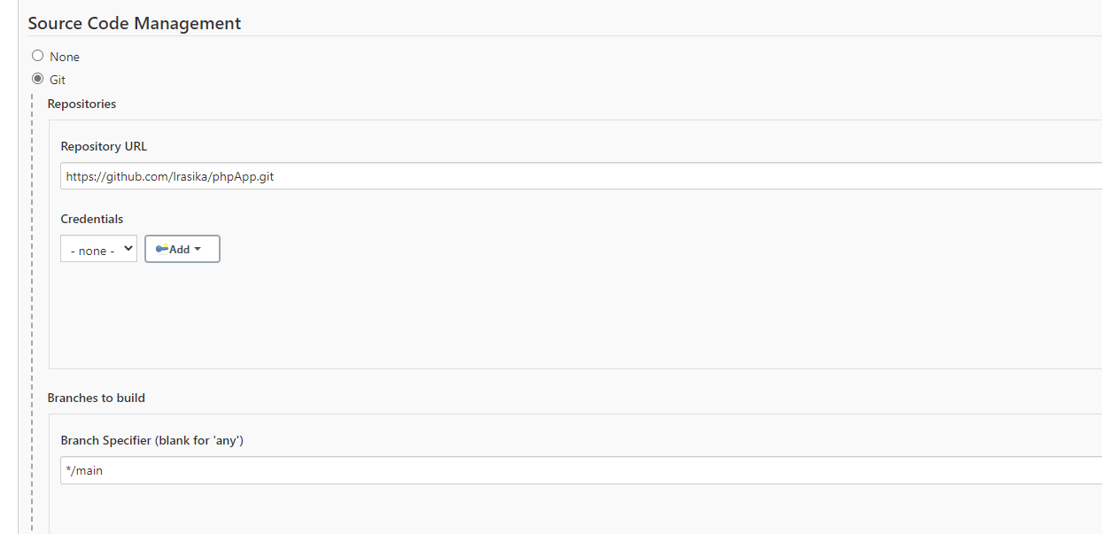

Pool SCM

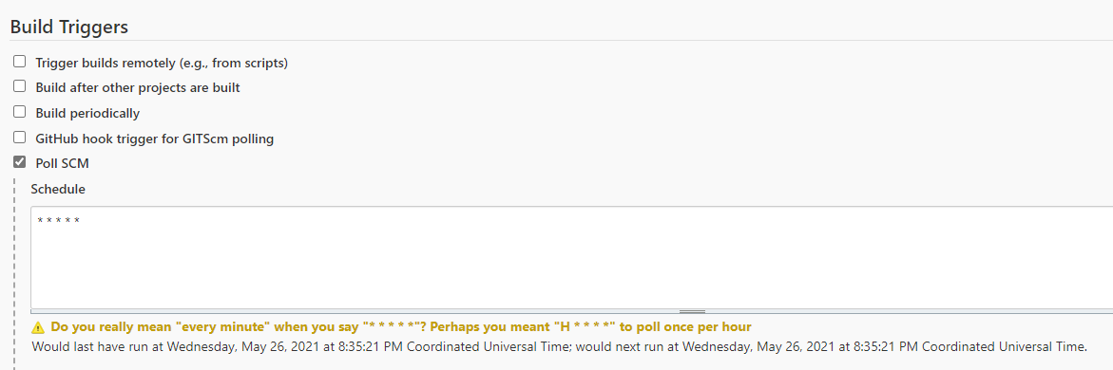

Docker Section Configuration

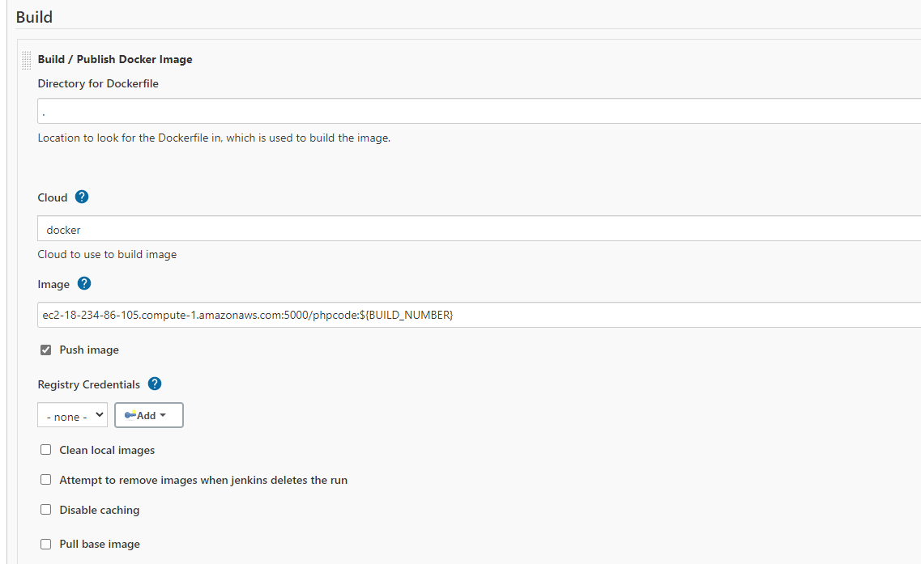

Console Log

Successfully built 5233f58b8907

Tagging built image with ec2-18-234-86-105.compute-1.amazonaws.com:5000/phpcode:20

Docker Build Response : 5233f58b8907

Pushing [ec2-18-234-86-105.compute-1.amazonaws.com:5000/phpcode:20]

The push refers to repository [ec2-18-234-86-105.compute-1.amazonaws.com:5000/phpcode]

fab9b0cf7ed1: Preparing

a4273e4d4fee: Preparing

83fe537781dd: Preparing

162ca78e9982: Preparing

622868f907ce: Preparing

3803562381ff: Preparing

2f140462f3bc: Preparing

63c99163f472: Preparing

ccdbb80308cc: Preparing

3803562381ff: Waiting

2f140462f3bc: Waiting

63c99163f472: Waiting

ccdbb80308cc: Waiting

a4273e4d4fee: Pushing [==================================================>] 512B

a4273e4d4fee: Pushing [==================================================>] 6.656kB

fab9b0cf7ed1: Pushing [> ] 1.536kB/152.9kB

162ca78e9982: Pushing 3.072kB

83fe537781dd: Pushing [> ] 1.536kB/152.9kB

83fe537781dd: Pushing [==================================================>] 160.3kB

fab9b0cf7ed1: Pushing [======================================> ] 118.8kB/152.9kB

fab9b0cf7ed1: Pushing [==================================================>] 159.7kB

622868f907ce: Pushing [> ] 528.2kB/173.5MB

622868f907ce: Pushing [> ] 1.611MB/173.5MB

622868f907ce: Pushing [> ] 3.282MB/173.5MB

622868f907ce: Pushing [=> ] 4.396MB/173.5MB

622868f907ce: Pushing [=> ] 4.935MB/173.5MB

622868f907ce: Pushing [=> ] 5.492MB/173.5MB

a4273e4d4fee: Pushed

622868f907ce: Pushing [==> ] 7.149MB/173.5MB

162ca78e9982: Pushed

622868f907ce: Pushing [==> ] 8.208MB/173.5MB

622868f907ce: Pushing [==> ] 9.879MB/173.5MB

622868f907ce: Pushing [===> ] 11.55MB/173.5MB

622868f907ce: Pushing [===> ] 13.19MB/173.5MB

fab9b0cf7ed1: Pushed

83fe537781dd: Pushed

622868f907ce: Pushing [====> ] 14.81MB/173.5MB

2f140462f3bc: Pushing [==================================================>] 512B

63c99163f472: Pushing [===============================> ] 512B/811B

2f140462f3bc: Pushing [==================================================>] 3.584kB

2f140462f3bc: Pushed

622868f907ce: Pushing [====> ] 15.36MB/173.5MB

63c99163f472: Pushing [==================================================>] 3.39kB

3803562381ff: Pushing [> ] 291.8kB/28.32MB

63c99163f472: Pushing [==================================================>] 7.184kB

622868f907ce: Pushing [====> ] 15.89MB/173.5MB

3803562381ff: Pushing [=> ] 881.7kB/28.32MB

63c99163f472: Pushing [==================================================>] 13.96kB

63c99163f472: Pushing [==================================================>] 15.36kB

63c99163f472: Pushed

3803562381ff: Pushing [===> ] 1.766MB/28.32MB

622868f907ce: Pushing [====> ] 16.43MB/173.5MB

3803562381ff: Pushing [====> ] 2.352MB/28.32MB

622868f907ce: Pushing [=====> ] 18.1MB/173.5MB

3803562381ff: Pushing [=====> ] 2.937MB/28.32MB

622868f907ce: Pushing [=====> ] 19.21MB/173.5MB

3803562381ff: Pushing [======> ] 3.527MB/28.32MB

622868f907ce: Pushing [=====> ] 20.32MB/173.5MB

3803562381ff: Pushing [========> ] 4.999MB/28.32MB

3803562381ff: Pushing [===========> ] 6.474MB/28.32MB

622868f907ce: Pushing [======> ] 20.86MB/173.5MB

3803562381ff: Pushing [===========> ] 6.787MB/28.32MB

622868f907ce: Pushing [======> ] 21.39MB/173.5MB

3803562381ff: Pushing [=============> ] 7.67MB/28.32MB

3803562381ff: Pushing [================> ] 9.439MB/28.32MB

3803562381ff: Pushing [===================> ] 11.21MB/28.32MB

3803562381ff: Pushing [======================> ] 12.68MB/28.32MB

622868f907ce: Pushing [======> ] 21.93MB/173.5MB

3803562381ff: Pushing [=======================> ] 13.27MB/28.32MB

3803562381ff: Pushing [=========================> ] 14.45MB/28.32MB

ccdbb80308cc: Pushing [> ] 543.2kB/72.7MB

3803562381ff: Pushing [===========================> ] 15.34MB/28.32MB

622868f907ce: Pushing [======> ] 23.01MB/173.5MB

ccdbb80308cc: Pushing [=> ] 1.634MB/72.7MB

3803562381ff: Pushing [============================> ] 15.93MB/28.32MB

ccdbb80308cc: Pushing [=> ] 2.714MB/72.7MB

3803562381ff: Pushing [=============================> ] 16.52MB/28.32MB

3803562381ff: Pushing [==============================> ] 17.11MB/28.32MB

ccdbb80308cc: Pushing [==> ] 3.774MB/72.7MB

622868f907ce: Pushing [======> ] 23.53MB/173.5MB

3803562381ff: Pushing [===============================> ] 17.7MB/28.32MB

ccdbb80308cc: Pushing [===> ] 4.871MB/72.7MB

3803562381ff: Pushing [================================> ] 18.29MB/28.32MB

ccdbb80308cc: Pushing [====> ] 5.958MB/72.7MB

3803562381ff: Pushing [=================================> ] 18.88MB/28.32MB

622868f907ce: Pushing [======> ] 24.07MB/173.5MB

ccdbb80308cc: Pushing [====> ] 7.069MB/72.7MB

3803562381ff: Pushing [==================================> ] 19.47MB/28.32MB

ccdbb80308cc: Pushing [=====> ] 8.141MB/72.7MB

3803562381ff: Pushing [===================================> ] 20.06MB/28.32MB

ccdbb80308cc: Pushing [======> ] 9.239MB/72.7MB

622868f907ce: Pushing [=======> ] 24.61MB/173.5MB

3803562381ff: Pushing [====================================> ] 20.65MB/28.32MB

ccdbb80308cc: Pushing [=======> ] 10.3MB/72.7MB

3803562381ff: Pushing [=====================================> ] 21.24MB/28.32MB

ccdbb80308cc: Pushing [=======> ] 11.35MB/72.7MB

3803562381ff: Pushing [======================================> ] 21.83MB/28.32MB

622868f907ce: Pushing [=======> ] 25.16MB/173.5MB

ccdbb80308cc: Pushing [========> ] 12.47MB/72.7MB

3803562381ff: Pushing [=======================================> ] 22.42MB/28.32MB

622868f907ce: Pushing [=======> ] 25.71MB/173.5MB

ccdbb80308cc: Pushing [=========> ] 13.58MB/72.7MB

3803562381ff: Pushing [========================================> ] 23.01MB/28.32MB

622868f907ce: Pushing [=======> ] 26.83MB/173.5MB

3803562381ff: Pushing [===========================================> ] 24.48MB/28.32MB

ccdbb80308cc: Pushing [=========> ] 14.14MB/72.7MB

3803562381ff: Pushing [============================================> ] 25.38MB/28.32MB

622868f907ce: Pushing [========> ] 27.94MB/173.5MB

3803562381ff: Pushing [==============================================> ] 26.27MB/28.32MB

3803562381ff: Pushing [===============================================> ] 27.18MB/28.32MB

622868f907ce: Pushing [========> ] 29.05MB/173.5MB

ccdbb80308cc: Pushing [==========> ] 15.25MB/72.7MB

3803562381ff: Pushing [=================================================> ] 28.06MB/28.32MB

3803562381ff: Pushing [==================================================>] 28.34MB

622868f907ce: Pushing [========> ] 30.17MB/173.5MB

ccdbb80308cc: Pushing [==========> ] 15.81MB/72.7MB

622868f907ce: Pushing [=========> ] 31.26MB/173.5MB

ccdbb80308cc: Pushing [===========> ] 16.34MB/72.7MB

622868f907ce: Pushing [=========> ] 32.38MB/173.5MB

ccdbb80308cc: Pushing [===========> ] 16.89MB/72.7MB

622868f907ce: Pushing [=========> ] 33.49MB/173.5MB

ccdbb80308cc: Pushing [===========> ] 17.43MB/72.7MB

622868f907ce: Pushing [=========> ] 34.03MB/173.5MB

ccdbb80308cc: Pushing [============> ] 18.5MB/72.7MB

622868f907ce: Pushing [==========> ] 35.15MB/173.5MB

ccdbb80308cc: Pushing [=============> ] 19.04MB/72.7MB

622868f907ce: Pushing [==========> ] 36.23MB/173.5MB

ccdbb80308cc: Pushing [=============> ] 19.59MB/72.7MB

622868f907ce: Pushing [==========> ] 37.32MB/173.5MB

622868f907ce: Pushing [===========> ] 38.4MB/173.5MB

ccdbb80308cc: Pushing [=============> ] 20.13MB/72.7MB

3803562381ff: Pushed

ccdbb80308cc: Pushing [==============> ] 20.67MB/72.7MB

622868f907ce: Pushing [===========> ] 39.49MB/173.5MB

622868f907ce: Pushing [===========> ] 40.6MB/173.5MB

ccdbb80308cc: Pushing [==============> ] 21.21MB/72.7MB

622868f907ce: Pushing [============> ] 41.71MB/173.5MB

ccdbb80308cc: Pushing [===============> ] 22.32MB/72.7MB

622868f907ce: Pushing [============> ] 42.8MB/173.5MB

622868f907ce: Pushing [============> ] 43.91MB/173.5MB

622868f907ce: Pushing [============> ] 45.01MB/173.5MB

622868f907ce: Pushing [=============> ] 46.13MB/173.5MB

622868f907ce: Pushing [=============> ] 47.78MB/173.5MB

622868f907ce: Pushing [==============> ] 48.89MB/173.5MB

622868f907ce: Pushing [==============> ] 50MB/173.5MB

ccdbb80308cc: Pushing [===============> ] 22.88MB/72.7MB

622868f907ce: Pushing [==============> ] 50.53MB/173.5MB

622868f907ce: Pushing [===============> ] 52.17MB/173.5MB

ccdbb80308cc: Pushing [================> ] 23.94MB/72.7MB

622868f907ce: Pushing [===============> ] 53.28MB/173.5MB

622868f907ce: Pushing [===============> ] 54.93MB/173.5MB

ccdbb80308cc: Pushing [================> ] 24.48MB/72.7MB

622868f907ce: Pushing [================> ] 56.04MB/173.5MB

622868f907ce: Pushing [================> ] 57.16MB/173.5MB

ccdbb80308cc: Pushing [=================> ] 25.55MB/72.7MB

622868f907ce: Pushing [================> ] 57.69MB/173.5MB

ccdbb80308cc: Pushing [==================> ] 26.63MB/72.7MB

622868f907ce: Pushing [================> ] 58.76MB/173.5MB

ccdbb80308cc: Pushing [==================> ] 27.17MB/72.7MB

622868f907ce: Pushing [=================> ] 60.98MB/173.5MB

ccdbb80308cc: Pushing [===================> ] 27.69MB/72.7MB

622868f907ce: Pushing [==================> ] 63.77MB/173.5MB

622868f907ce: Pushing [==================> ] 64.87MB/173.5MB

ccdbb80308cc: Pushing [===================> ] 28.76MB/72.7MB

622868f907ce: Pushing [===================> ] 65.96MB/173.5MB

ccdbb80308cc: Pushing [====================> ] 29.29MB/72.7MB

ccdbb80308cc: Pushing [====================> ] 30.36MB/72.7MB

ccdbb80308cc: Pushing [======================> ] 32.01MB/72.7MB

ccdbb80308cc: Pushing [=======================> ] 33.66MB/72.7MB

ccdbb80308cc: Pushing [=======================> ] 34.74MB/72.7MB

622868f907ce: Pushing [===================> ] 67.04MB/173.5MB

622868f907ce: Pushing [===================> ] 68.15MB/173.5MB

ccdbb80308cc: Pushing [========================> ] 35.85MB/72.7MB

ccdbb80308cc: Pushing [=========================> ] 36.96MB/72.7MB

622868f907ce: Pushing [===================> ] 69.23MB/173.5MB

ccdbb80308cc: Pushing [==========================> ] 38.07MB/72.7MB

622868f907ce: Pushing [====================> ] 70.33MB/173.5MB

ccdbb80308cc: Pushing [==========================> ] 38.6MB/72.7MB

622868f907ce: Pushing [====================> ] 71.43MB/173.5MB

ccdbb80308cc: Pushing [===========================> ] 39.67MB/72.7MB

622868f907ce: Pushing [====================> ] 72.55MB/173.5MB

ccdbb80308cc: Pushing [============================> ] 40.76MB/72.7MB

622868f907ce: Pushing [=====================> ] 73.64MB/173.5MB

ccdbb80308cc: Pushing [============================> ] 41.84MB/72.7MB

622868f907ce: Pushing [=====================> ] 74.74MB/173.5MB

ccdbb80308cc: Pushing [=============================> ] 42.95MB/72.7MB

622868f907ce: Pushing [=====================> ] 75.82MB/173.5MB

ccdbb80308cc: Pushing [==============================> ] 44.05MB/72.7MB

622868f907ce: Pushing [======================> ] 76.88MB/173.5MB

ccdbb80308cc: Pushing [===============================> ] 45.16MB/72.7MB

ccdbb80308cc: Pushing [===============================> ] 45.69MB/72.7MB

622868f907ce: Pushing [======================> ] 78MB/173.5MB

622868f907ce: Pushing [======================> ] 79.11MB/173.5MB

ccdbb80308cc: Pushing [================================> ] 46.75MB/72.7MB

622868f907ce: Pushing [=======================> ] 80.23MB/173.5MB

622868f907ce: Pushing [=======================> ] 81.9MB/173.5MB

ccdbb80308cc: Pushing [================================> ] 47.31MB/72.7MB

622868f907ce: Pushing [========================> ] 83.57MB/173.5MB

ccdbb80308cc: Pushing [=================================> ] 48.97MB/72.7MB

622868f907ce: Pushing [========================> ] 84.12MB/173.5MB

622868f907ce: Pushing [========================> ] 85.24MB/173.5MB

ccdbb80308cc: Pushing [==================================> ] 50.05MB/72.7MB

622868f907ce: Pushing [=========================> ] 86.91MB/173.5MB

ccdbb80308cc: Pushing [===================================> ] 51.12MB/72.7MB

622868f907ce: Pushing [=========================> ] 88.02MB/173.5MB

ccdbb80308cc: Pushing [===================================> ] 51.66MB/72.7MB

622868f907ce: Pushing [=========================> ] 89.14MB/173.5MB

ccdbb80308cc: Pushing [====================================> ] 52.77MB/72.7MB

622868f907ce: Pushing [==========================> ] 90.25MB/173.5MB

ccdbb80308cc: Pushing [=====================================> ] 53.88MB/72.7MB

622868f907ce: Pushing [==========================> ] 90.81MB/173.5MB

ccdbb80308cc: Pushing [=====================================> ] 54.96MB/72.7MB

622868f907ce: Pushing [==========================> ] 91.92MB/173.5MB

622868f907ce: Pushing [==========================> ] 93.59MB/173.5MB

ccdbb80308cc: Pushing [======================================> ] 56.07MB/72.7MB

622868f907ce: Pushing [===========================> ] 95.27MB/173.5MB

ccdbb80308cc: Pushing [======================================> ] 56.63MB/72.7MB

622868f907ce: Pushing [===========================> ] 96.94MB/173.5MB

ccdbb80308cc: Pushing [=======================================> ] 57.19MB/72.7MB

622868f907ce: Pushing [============================> ] 98.61MB/173.5MB

622868f907ce: Pushing [============================> ] 99.72MB/173.5MB

622868f907ce: Pushing [=============================> ] 101.4MB/173.5MB

622868f907ce: Pushing [=============================> ] 103.6MB/173.5MB

ccdbb80308cc: Pushing [=======================================> ] 57.71MB/72.7MB

622868f907ce: Pushing [==============================> ] 105.3MB/173.5MB

622868f907ce: Pushing [==============================> ] 107MB/173.5MB

622868f907ce: Pushing [===============================> ] 108.6MB/173.5MB

622868f907ce: Pushing [===============================> ] 110.3MB/173.5MB

ccdbb80308cc: Pushing [========================================> ] 58.25MB/72.7MB

622868f907ce: Pushing [===============================> ] 110.8MB/173.5MB

ccdbb80308cc: Pushing [========================================> ] 58.78MB/72.7MB

622868f907ce: Pushing [================================> ] 111.9MB/173.5MB

622868f907ce: Pushing [================================> ] 113MB/173.5MB

ccdbb80308cc: Pushing [========================================> ] 59.33MB/72.7MB

622868f907ce: Pushing [=================================> ] 114.6MB/173.5MB

ccdbb80308cc: Pushing [=========================================> ] 59.86MB/72.7MB

622868f907ce: Pushing [=================================> ] 116.9MB/173.5MB

622868f907ce: Pushing [==================================> ] 118.5MB/173.5MB

622868f907ce: Pushing [==================================> ] 120.1MB/173.5MB

622868f907ce: Pushing [==================================> ] 121.2MB/173.5MB

622868f907ce: Pushing [===================================> ] 122.3MB/173.5MB

622868f907ce: Pushing [===================================> ] 124MB/173.5MB

622868f907ce: Pushing [====================================> ] 126.2MB/173.5MB

ccdbb80308cc: Pushing [=========================================> ] 60.38MB/72.7MB

622868f907ce: Pushing [====================================> ] 127.3MB/173.5MB

622868f907ce: Pushing [=====================================> ] 128.4MB/173.5MB

622868f907ce: Pushing [=====================================> ] 129.5MB/173.5MB

622868f907ce: Pushing [=====================================> ] 130.6MB/173.5MB

ccdbb80308cc: Pushing [=========================================> ] 60.91MB/72.7MB

622868f907ce: Pushing [=====================================> ] 131.1MB/173.5MB

622868f907ce: Pushing [=====================================> ] 131.6MB/173.5MB

622868f907ce: Pushing [======================================> ] 133.2MB/173.5MB

622868f907ce: Pushing [======================================> ] 134.3MB/173.5MB

622868f907ce: Pushing [=======================================> ] 135.4MB/173.5MB

ccdbb80308cc: Pushing [==========================================> ] 61.45MB/72.7MB

622868f907ce: Pushing [=======================================> ] 137.1MB/173.5MB

622868f907ce: Pushing [=======================================> ] 138.8MB/173.5MB

ccdbb80308cc: Pushing [==========================================> ] 61.99MB/72.7MB

622868f907ce: Pushing [========================================> ] 140.4MB/173.5MB

ccdbb80308cc: Pushing [==========================================> ] 62.52MB/72.7MB

622868f907ce: Pushing [========================================> ] 141.5MB/173.5MB

ccdbb80308cc: Pushing [===========================================> ] 63.06MB/72.7MB

ccdbb80308cc: Pushing [============================================> ] 64.16MB/72.7MB

622868f907ce: Pushing [========================================> ] 142.1MB/173.5MB

ccdbb80308cc: Pushing [============================================> ] 65.25MB/72.7MB

622868f907ce: Pushing [=========================================> ] 142.6MB/173.5MB

ccdbb80308cc: Pushing [=============================================> ] 65.81MB/72.7MB

622868f907ce: Pushing [=========================================> ] 143.7MB/173.5MB

ccdbb80308cc: Pushing [==============================================> ] 66.91MB/72.7MB

622868f907ce: Pushing [=========================================> ] 144.8MB/173.5MB

ccdbb80308cc: Pushing [==============================================> ] 67.46MB/72.7MB

ccdbb80308cc: Pushing [==============================================> ] 68MB/72.7MB

622868f907ce: Pushing [==========================================> ] 145.9MB/173.5MB

622868f907ce: Pushing [==========================================> ] 146.9MB/173.5MB

622868f907ce: Pushing [==========================================> ] 147.5MB/173.5MB

ccdbb80308cc: Pushing [===============================================> ] 69.6MB/72.7MB

622868f907ce: Pushing [==========================================> ] 148MB/173.5MB

ccdbb80308cc: Pushing [================================================> ] 70.13MB/72.7MB

ccdbb80308cc: Pushing [================================================> ] 70.65MB/72.7MB

622868f907ce: Pushing [==========================================> ] 148.5MB/173.5MB

622868f907ce: Pushing [==========================================> ] 149MB/173.5MB

ccdbb80308cc: Pushing [=================================================> ] 71.74MB/72.7MB

ccdbb80308cc: Pushing [==================================================>] 72.79MB

622868f907ce: Pushing [===========================================> ] 149.6MB/173.5MB

622868f907ce: Pushing [===========================================> ] 150.1MB/173.5MB

ccdbb80308cc: Pushing [==================================================>] 73.84MB

622868f907ce: Pushing [===========================================> ] 151.2MB/173.5MB

ccdbb80308cc: Pushing [==================================================>] 74.91MB

ccdbb80308cc: Pushing [==================================================>] 75.07MB

ccdbb80308cc: Pushed

622868f907ce: Pushing [===========================================> ] 151.7MB/173.5MB

622868f907ce: Pushing [===========================================> ] 152.2MB/173.5MB

622868f907ce: Pushing [============================================> ] 153.4MB/173.5MB

622868f907ce: Pushing [============================================> ] 153.9MB/173.5MB

622868f907ce: Pushing [============================================> ] 154.9MB/173.5MB

622868f907ce: Pushing [============================================> ] 156MB/173.5MB

622868f907ce: Pushing [=============================================> ] 157.1MB/173.5MB

622868f907ce: Pushing [=============================================> ] 158.7MB/173.5MB

622868f907ce: Pushing [==============================================> ] 159.8MB/173.5MB

622868f907ce: Pushing [==============================================> ] 160.9MB/173.5MB

622868f907ce: Pushing [==============================================> ] 161.9MB/173.5MB

622868f907ce: Pushing [===============================================> ] 164.1MB/173.5MB

622868f907ce: Pushing [===============================================> ] 165.2MB/173.5MB

622868f907ce: Pushing [================================================> ] 166.8MB/173.5MB

622868f907ce: Pushing [================================================> ] 168.5MB/173.5MB

622868f907ce: Pushing [================================================> ] 169MB/173.5MB

622868f907ce: Pushing [================================================> ] 169.5MB/173.5MB

622868f907ce: Pushing [=================================================> ] 170MB/173.5MB

622868f907ce: Pushing [=================================================> ] 170.6MB/173.5MB

622868f907ce: Pushing [=================================================> ] 171.1MB/173.5MB

622868f907ce: Pushing [=================================================> ] 171.6MB/173.5MB

622868f907ce: Pushing [=================================================> ] 172.1MB/173.5MB

622868f907ce: Pushing [=================================================> ] 172.7MB/173.5MB

622868f907ce: Pushing [==================================================>] 173.7MB

622868f907ce: Pushing [==================================================>] 175.4MB

622868f907ce: Pushing [==================================================>] 175.9MB

622868f907ce: Pushing [==================================================>] 176.5MB

622868f907ce: Pushing [==================================================>] 177.5MB

622868f907ce: Pushing [==================================================>] 178.4MB

622868f907ce: Pushed

20: digest: sha256:a1092377c461bdaa9fef42cf1045b2959b4f1ac89071cdd542983eb5651c3604 size: 2199

Docker Build Done

Finished: SUCCESS

Docker Registry Frontend

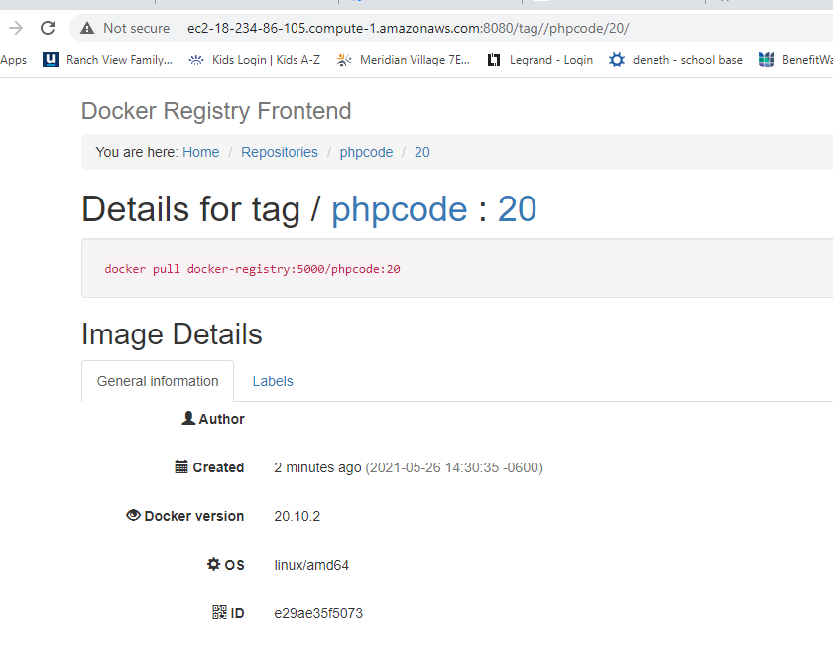

Setup

3 EC2 Instances with Ubuntu 18.04

1 as the Jenkins server

1 as a local docker registry

1 as Jenkins slave

Jenkins server config

sudo apt install default-jdk

sudo update-alternatives --config java

wget -q -O - https://pkg.jenkins.io/debian/jenkins.io.key | sudo apt-key add -

Then add the following entry in your /etc/apt/sources.list:

echo deb https://pkg.jenkins.io/debian-stable binary/ | sudo tee /etc/apt/sources.list.d/jenkins.list

Update your local package index, then finally install Jenkins:

sudo apt-get update

sudo apt-get install jenkins

sudo cat /var/lib/jenkins/secrets/initialAdminPassword

Install Docker

sudo apt-get update

sudo apt-get install apt-transport-https ca-certificates curl gnupg- agent software-properties-common

curl -fsSL https://download.docker.com/linux/ubuntu/gpg | sudo apt-key add -

sudo apt install docker.io

sudo apt install docker-compose

sudo groupadd docker

sudo usermod -aG docker $USER

newgrp docker

docker registry UI servers

sudo vi docker-compose.yml

yml file content

version: "3"

services:

docker-registry:

image: registry:2

container_name: docker-registry

ports:

- 5000:5000

restart: always

volumes:

- ./docker-registry:/var/lib/registry

docker-registry-ui:

image: konradkleine/docker-registry-frontend:v2

container_name: docker-registry-ui

ports:

- 8080:80

environment:

ENV_DOCKER_REGISTRY_HOST: docker-registry

ENV_DOCKER_REGISTRY_PORT: 5000

mkdit volume

docker-compose -f docker-compose.yml up

docker client machine

sudo vi /etc/hosts

add the following entry

172.31.25.34 ec2-18-234-86-105.compute-1.amazonaws.com

sudo vi /etc/docker/daemon.json

{

"insecure-registries" : ["ec2-18-234-86-105.compute-1.amazonaws.com:5000"]

}

sudo service docker stop

sudo service docker start

ubuntu@ip-172-31-31-131:~/docker-registry-app$ docker images

REPOSITORY TAG IMAGE ID CREATED SIZE

ubuntu@ip-172-31-31-131:~/docker-registry-app$

ubuntu@ip-172-31-31-131:~/docker-registry-app$

ubuntu@ip-172-31-31-131:~/docker-registry-app$ docker pull alpine

Using default tag: latest

latest: Pulling from library/alpine

540db60ca938: Pull complete

Digest: sha256:69e70a79f2d41ab5d637de98c1e0b055206ba40a8145e7bddb55ccc04e13cf8f

Status: Downloaded newer image for alpine:latest

docker.io/library/alpine:latest

ubuntu@ip-172-31-31-131:~/docker-registry-app$

ubuntu@ip-172-31-31-131:~/docker-registry-app$

ubuntu@ip-172-31-31-131:~/docker-registry-app$ docker tag alpine:latest ec2-18-234-86-105.compute-1.amazonaws.com:5000/lalith/alpine-lalith:v1

ubuntu@ip-172-31-31-131:~/docker-registry-app$

ubuntu@ip-172-31-31-131:~/docker-registry-app$

ubuntu@ip-172-31-31-131:~/docker-registry-app$ docker images

REPOSITORY TAG IMAGE ID CREATED SIZE

alpine latest 6dbb9cc54074 6 weeks ago 5.61MB

ec2-18-234-86-105.compute-1.amazonaws.com:5000/lalith/alpine-lalith v1 6dbb9cc54074 6 weeks ago 5.61MB

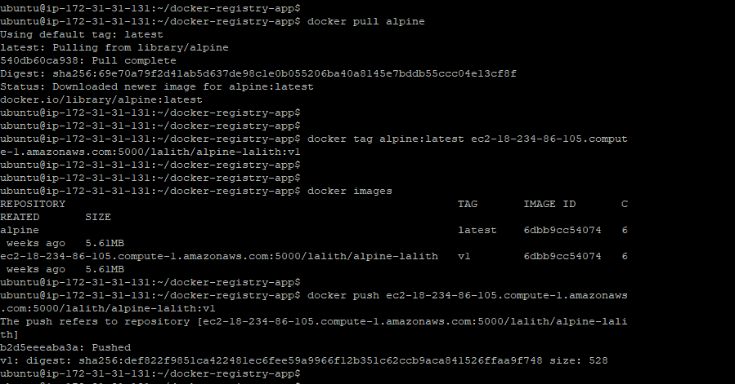

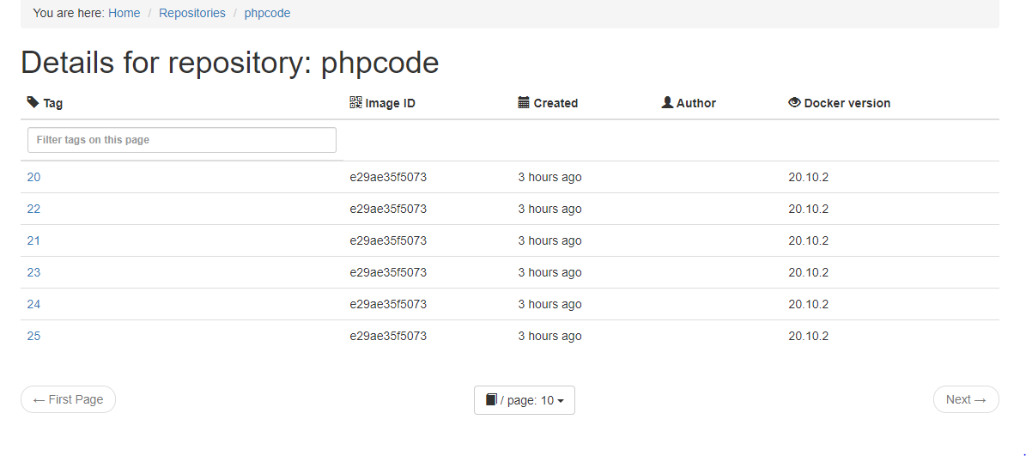

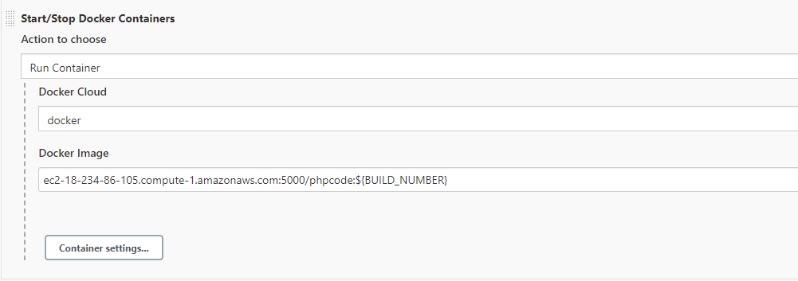

Jenkins output

Successfully built 4ec4d65f42c8

Tagging built image with ec2-18-234-86-105.compute-1.amazonaws.com:5000/phpcode:29

Docker Build Response : 4ec4d65f42c8

Pushing [ec2-18-234-86-105.compute-1.amazonaws.com:5000/phpcode:29]

The push refers to repository [ec2-18-234-86-105.compute-1.amazonaws.com:5000/phpcode]

c98c79fde9d5: Preparing

acf3c0bdc511: Preparing

8acd908920d6: Preparing

a9c0532fef78: Preparing

7d62b7c6abca: Preparing

b83b80ed59ef: Preparing

2f140462f3bc: Preparing

63c99163f472: Preparing

ccdbb80308cc: Preparing

b83b80ed59ef: Waiting

2f140462f3bc: Waiting

63c99163f472: Waiting

ccdbb80308cc: Waiting

a9c0532fef78: Layer already exists

c98c79fde9d5: Layer already exists

acf3c0bdc511: Layer already exists

8acd908920d6: Layer already exists

7d62b7c6abca: Layer already exists

63c99163f472: Layer already exists

b83b80ed59ef: Layer already exists

2f140462f3bc: Layer already exists

ccdbb80308cc: Layer already exists

29: digest: sha256:451b1a57ea539d0dff3d5beea03420fe14ef51db265cb0539a768969d14d643b size: 2199

Docker Build Done

Pulling image ec2-18-234-86-105.compute-1.amazonaws.com:5000/phpcode:29

29:Pulling from phpcodenull:Digest: sha256:451b1a57ea539d0dff3d5beea03420fe14ef51db265cb0539a768969d14d643bnull:Status: Image is up to date for ec2-18-234-86-105.compute-1.amazonaws.com:5000/phpcode:29Starting container for image ec2-18-234-86-105.compute-1.amazonaws.com:5000/phpcode:29

Started container 1f1df1520f2a23cce00845911324f09d85b89d253fdab6170277a479960ebe22

Finished: SUCCESS

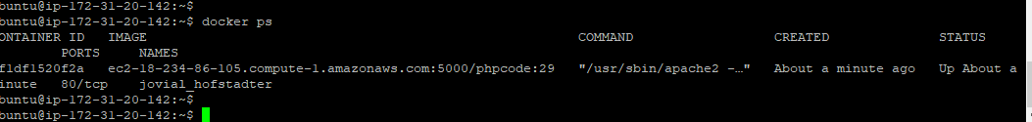

Local décor repo and Jenkins results

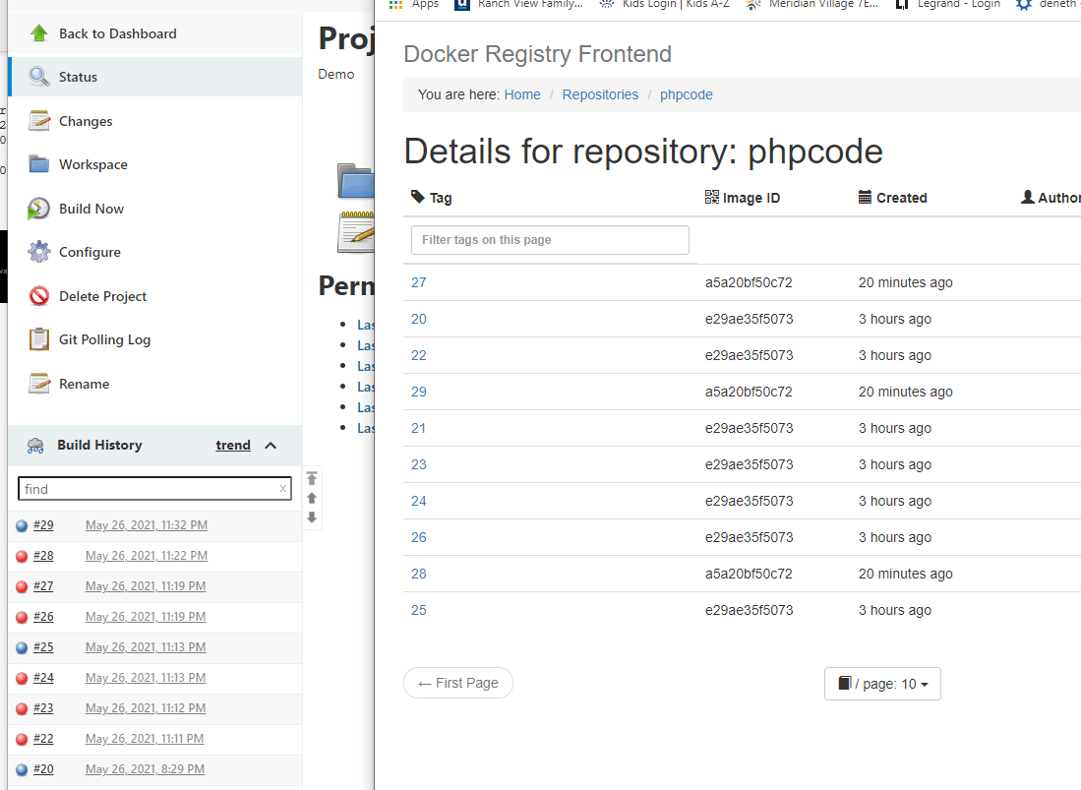

Access the running container

